Lib Guide
World History Biography Project
- Go to the North Dallas High School web site home page.
http://www.dallasisd.org/northdallas
- Click on the Library tab at the top.
- Click on the Databases tab on the left-hand side.
- For general information about your topic, click on:
Britannica or World Book
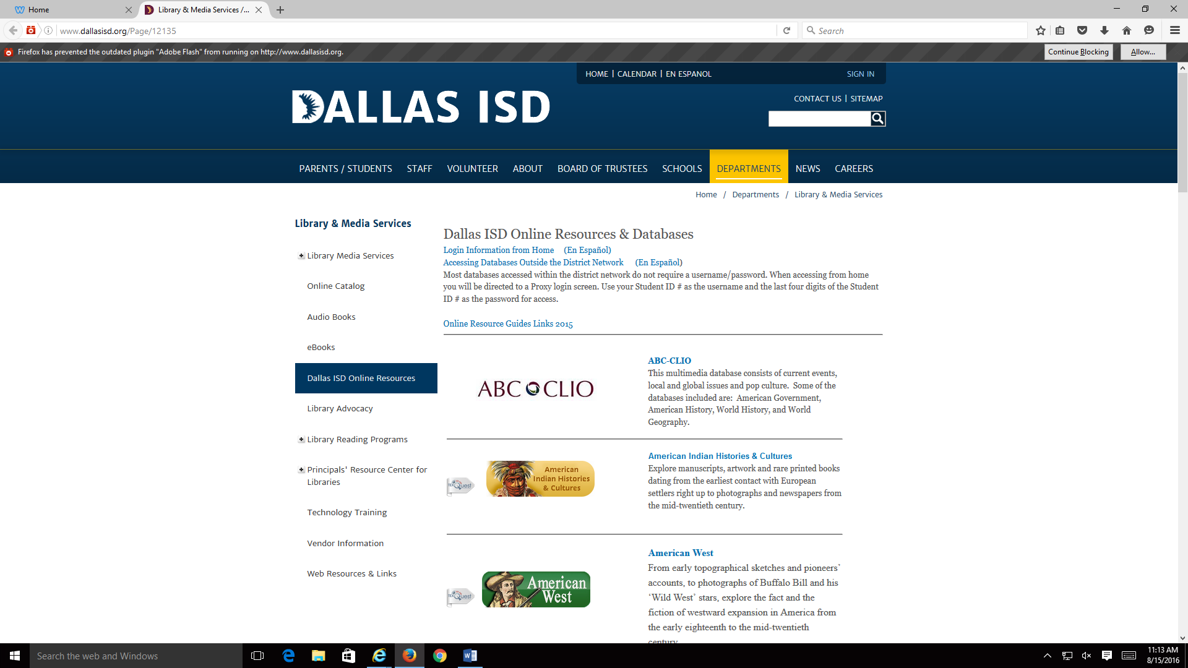

- For more detailed information:
- Go to ABC Clio Database and click on either World History: Ancient and Medieval Eras OR World History: The Modern Era.
- Go to Gale Databases and click on Research in Context.
- Go to the Ebsco Databases and click on History Reference Center After you type in your search term look on the left at Source Type. Uncheck All Results and then check the Biography box.

- For images in your project, click on Image Quest or Clip Art ETC.

Don’t forget to cite your sources.

